

**STEP 1:**

**FIND THE ZOOM ICON ON YOUR COMPUTER DESKTOP**

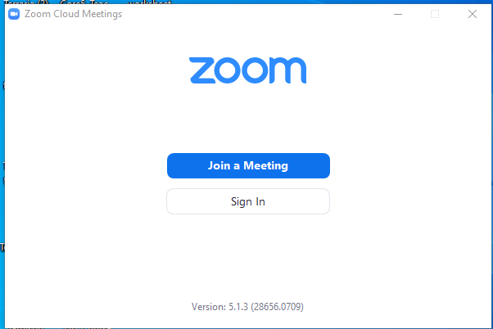

**STEP 2:**

**CLICK SIGN IN**

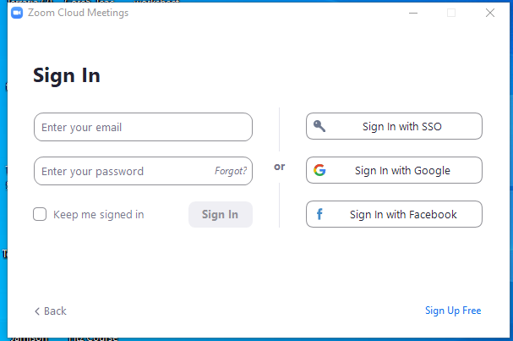

**STEP 3:**

**CLICK SIGN IN WITH SSO**

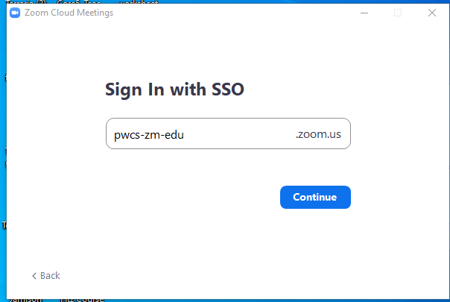

**STEP 4:**

**FILL THE BOX ABOVE WITH OUR DOMAN**

**PWCS-ZM-EDU**

**THEN CLICK CONTINUE**

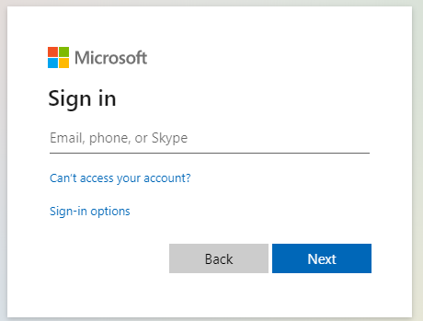

**STEP 5:**

**FILL IN YOUR PWCS EMAIL**

[**USERNAME@PWCS-EDU.ORG**](mailto:USERNAME@PWCS-EDU.ORG)

**THEN CLICK NEXT**

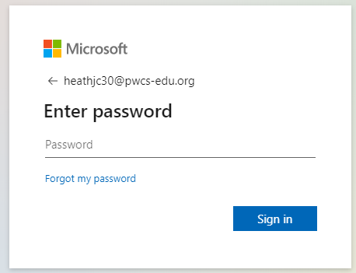

**STEP 6:**

**TYPE YOUR PWCS PASSWORD**

**THEN CLICK SIGN IN**

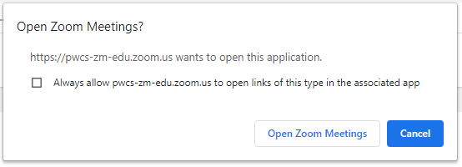

**STEP 7:**

**CHECK THE BOX TO ALWAYS OPEN ZOOM**

**THEN CLICK OPEN MEETINGS**

OR

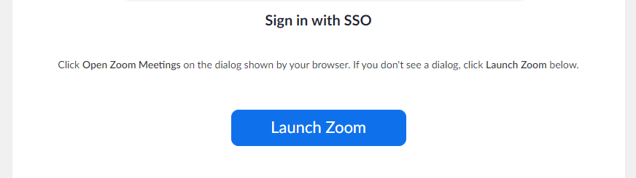

**STEP 7:**

**OR JUST CLICK THE LAUNCH ZOOM BUTTON**

**YOUR DEVICE IS NOW AUTHENTICATED WITH ZOOM AND READY FOR A SECURE CLASSROOM**